MC33063/MC34063 PWM Controller Model

1 Scope
This document contains the SPICE model along with an application’s circuit for verification of the On Semiconductor MC33063/MC34063 pulse width modulation controller. A summary of the analysis and key results are provided below:

MC33063/MC34063 PWM Controller
Test Parameter | Data Sheet Specification | Simulation Result | Results
Nominal Oscillator Frequency | ≈ 28µS | 26.4µS | Correlates
Nominal Oscillator Amplitude | 800mVp-p | 800mVp-p | Correlates
Current limit threshold | 300mV (typ) | 300mV | Correlates

This set of parameters is specified by the manufacturer’s published data sheet. The operating temperature of the model was 25°C. A 1nF capacitor was used at Vcc = 5V_{DC} for the oscillator testing.

2 Functional Description
The MC34063 is a monolithic control circuit for DC-DC converters. The device includes a reference, comparator, oscillator, pulse width modulator, and an active current limit circuit. The device operates over the voltage range of 3 to 40 V_{DC} and has an internal 1.5A Darlington output stage. The output stage provides active source / sink capability.

3 Model Description
The control circuit was decomposed into elemental blocks, and then modeled accordingly. Using a schematic capture for SPICE, a model of the controller was then created using the modules, and a corresponding netlist was generated. The model was then applied in one of the applications circuits specified by the manufacturer’s data sheets for verification.
- The oscillator was modeled using a SPICE switch to provide voltage detection and hysteresis, and a behavioral switched current pump for the timing capacitor. The switch contacts were used to derive a reset pulse for the pulse width modulation SR register. The peak to peak amplitude and DC offset were determined from the published data sheet, and applied to the current pump and switch.
- The current control circuit was modeled by comparing the differential voltage to an internal voltage source. This is to provide the ability to apply tolerances. The voltage control circuit was modeled using a set of behavioral voltage sources for the digital logic, comparator, and level shifters, and an independent 1.25V_{DC} reference. This too is to provide the ability to apply tolerances.
- The output stage was created using bipolar transistor models available with SPICE.

4 Methods of Verification
A model of the MC34063 driver was created using SPICE (figure1, table1). The model was tested as per the manufacturer’s datasheet into a 1000pF capacitive load. The model was driven by simple pulsed voltage sources, and the output rise times and propagation delays were monitored. As per the published datasheet, the model was run at 15 V_{VDD}, 400 V_{VS}, and 25°C operating temperature. These values were then compared to the manufacturer’s published data for correlation.

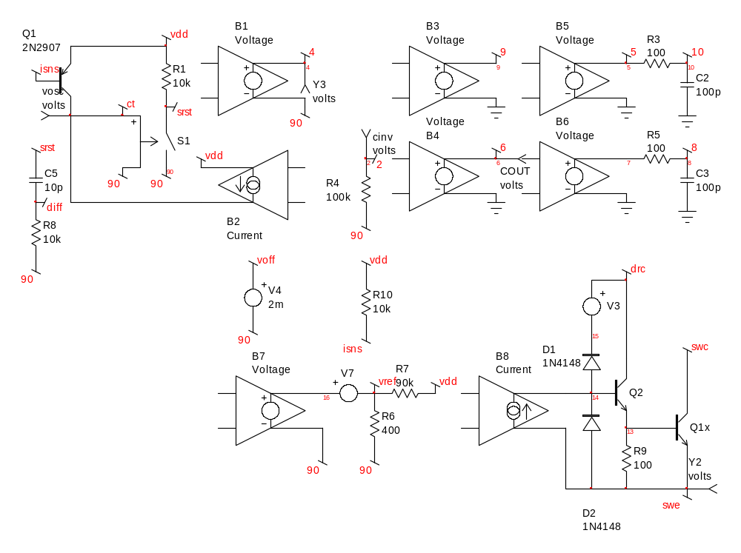
Figure 1: SPICE schematic diagram of the MC34063 controller model
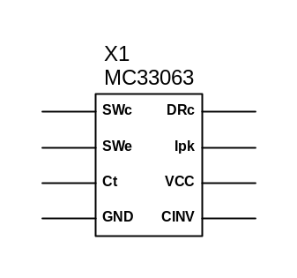
Figure 2: SPICE symbol created for the model

Table 1: Spice Netlist MC34063 driver model

*==========================================================
* MC34063
* ON SEMICONDUTOR
* 1.5 A, Step-Up/Down/Inverting Switching Regulator
*
* This model was developed for On Semiconductor by:
* AEI Systems, LLC
* 5777 W. Century Blvd. Suite 876
* Los Angeles, California 90045
* Copyright 2002, all rights reserved.
*
* This model is subject to change without notice.
* Users may not directly or indirectly re-sell or
* re-distribute this model. This model may not
* be used, modified, or altered
* without the consent of On Semiconductor.
*
* For more information regarding modeling services,
* model libraries and simulation products, please
* call AEi Systems at (310) 863-8034, or contact
* AEi by email: info@aeng.com. http://www.AENG.com
*
* Revision: 2/18/02, version 1.1
*==========================================================
**********
*SRC=MC33063;MC33063;Regulators;On Semiconductor;1.5A
*SYM=MC34063
.SUBCKT MC33063 swc swe ct 90 2 vdd isns drc
* SW-col SW-em Ct gnd cinv vdd isns drive col
*DC-DC controller
B5 5 0 V=~(v(9)&v(8))
Q1 ct isns vdd QN2907
.MODEL QN2907 PNP BF=200 BR=6 CJC=19PF CJE=23PF IKF=100E-3
+ IS=1.1E-12 ISE=1.3E-11 MJC=.2 MJE=1.25 NE=1.9 NF=1.21 RC=.6
+ TF=5E-10 TR=34E-9 VAF=50 VJC=.5 VJE=.85 XTB=1.5
B6 7 0 V=~(v(4)&v(10))
R3 5 10 100
R9 13 swe 100
C2 10 0 100p IC=5
R4 2 90 10MEG
R5 7 8 100
C3 8 0 100p IC=0
S1 srst 90 ct 90 _S2_mod
.MODEL _S2_mod SW VT=1.75 VH=1.25
R1 srst vdd 10k
Q2 drc 14 13 _Q3_mod
.MODEL _Q3_mod NPN BF=50
B4 6 0 V=v(2,90) > (v(vref,90) + v(voff,90)) ? 0 : v(vdd)
B2 vdd ct I=V(srst,90) > 3 ? 35U : -220U
B3 9 0 V=(v(6,90) > 3) ? v(diff,90) > 1 ? 0 : v(vdd)
B7 16 90 V=V(vdd,90)-1.5 > 1.25 ? 1.25 : V(vdd,90)-1.25 < 0 ? 0 :V(vdd,90)-1.25
V7 16 vref
R6 vref 90 400
R7 vref vdd 90k
Q1x swc 13 swe _Q4_mod
.MODEL _Q4_mod NPN BF=50 RC=.25 RE=.25 TF=0
R8 diff 90 10k
D1 14 15 DN4148
.MODEL DN4148 D BV=100V CJO=4PF IS=7E-09 M=.45 N=2 RS=.8
+ TT=6E-09 VJ=.6V
D2 swe 14 DN4148
V3 drc 15 DC=700m
B8 swe 14 I=v(5) > 2.5 ? 1m : -1m
V4 voff 90 DC=2m
C5 srst diff 10p
B1 4 90 V=(v(6,90) > 3) ? (v(diff,90) > -1) ? v(vdd) : 0
R10 vdd isns 10k
.ENDS
**********
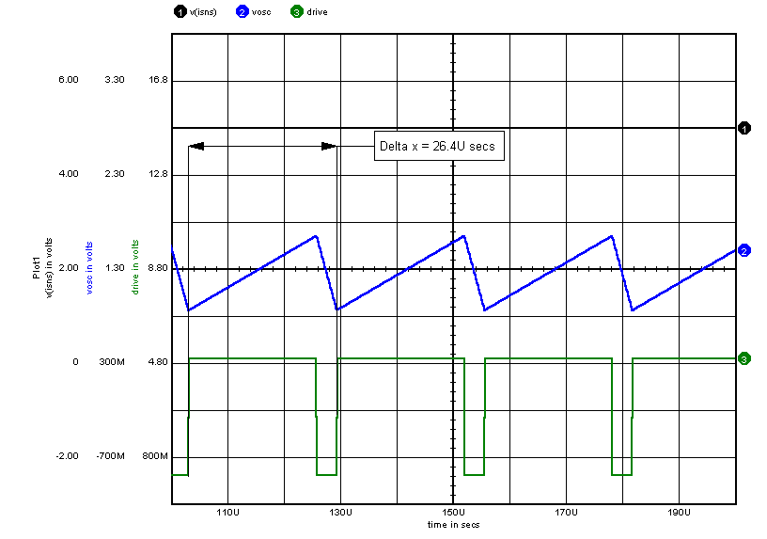Figure 3: Oscillator Simulation. The bottom trace represents an internal PWM reset pulse derived from the timing circuit.
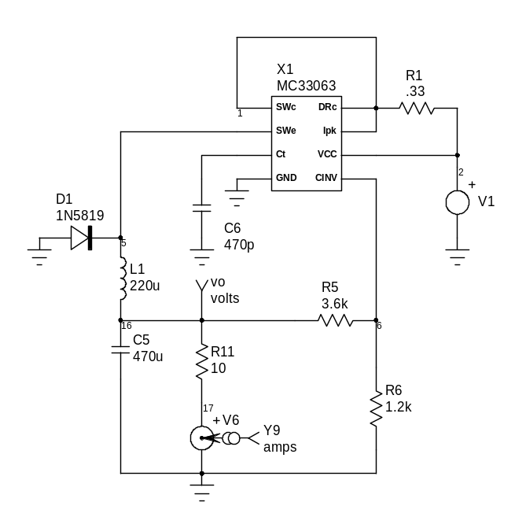
Figure 4: Application test circuit.

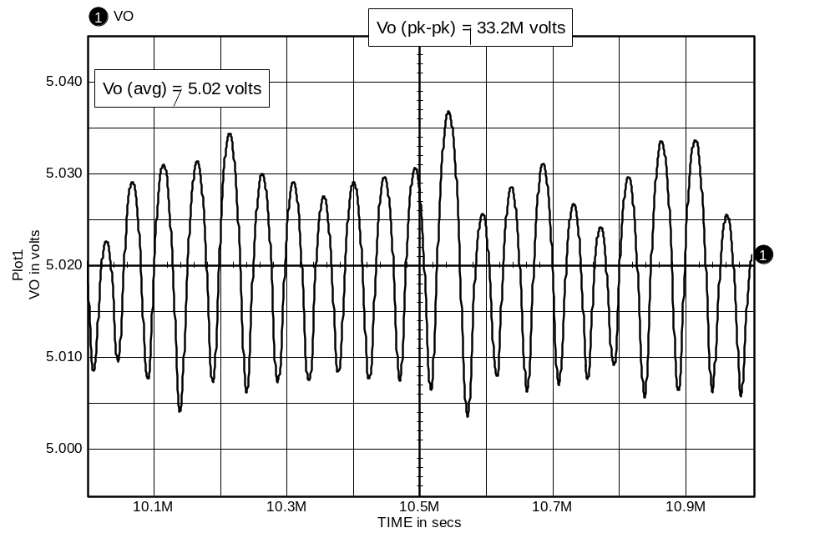Figure 5: Output voltage from application test circuit. DC-DC buck converter, 25Vin, 5Vout, 500mA load.

5 Conclusions
The model of the MC33063/MC34063 driver correlates very well with the manufacturer’s datasheet. This data should be verified against actual hardware for further confirmation.

